EXPERIMENT - 8

AIM:- (i) Utilize website crawling OSINT tools to gather a comprehensive list of URLs, internal links, and structure of the website.
(ii) Use OSINT Tools to identify the technologies and frameworks used by the website, such as content management systems (CMS), server software, programming languages, or analytics tools and create vulnerability reports.(penetration testing tools)

THEORY:-
I. Website Crawling and OSINT Tools:
Website crawler visits a website, reads every page, and meticulously follows every link it finds. It then visits those linked pages, repeating the process until it's explored a significant portion of the website. This collected data becomes a goldmine of information for analysis using OSINT techniques.
Choosing a Website Crawling Tool:
- Free Crawlers:
  - Photon: This Python program excels at OSINT tasks. It can unearth URLs, email addresses, social media connections, and more.
  - Scrapy: A powerful Python framework for building custom web crawlers, allowing for highly specific information gathering.
- Paid Options (for extensive needs):
  - Screaming Frog: User-friendly with features for crawling, SEO analysis, and broken link detection.
  - DeepCrawl: Handles large websites with ease, offering advanced reporting and analytics.
Crawling and OSINT Analysis:
- Set the Crawl Scope: Tell your chosen tool how much of the website to explore (entire site, specific sections, etc.).
- Crawling Magic: The tool scurries around the website, gathering data like:
  - URLs: A complete list of all visited pages.
  - Internal Links: The connections between pages within the website.
  - Content: Text, images, and other website elements.
- Unlocking Insights: Analyze the data to understand:
  - Website Structure: How pages are interconnected and organized (think of it as a website map).
  - Content Distribution: The dominant content types (text, images, videos) and their placement.
  - Potential Security Issues: Look for exposed sensitive information, but avoid exploiting it (e.g., email addresses, server details).
II. OSINT Tools for Identifying Technologies and Frameworks:
- Website Fingerprinting: These tools act like digital detectives, analyzing a website's response to identify the technologies powering it.
  - Free Options:
    - Wappalyzer: This browser extension and online tool reveals technologies like CMS, programming languages, and analytics tools used on a website.
    - BuiltWith: This online service acts like a website detective, piecing together clues from various data points to identify website technologies.
  - Paid Options (for advanced needs):
    - Netsparker: A comprehensive web vulnerability scanner that also identifies website technologies.
- Vulnerability Reporting (Advanced): This is a complex step best left to professionals with specialized tools and expertise.
  - Penetration testing tools like Metasploit or Nessus can be used to identify potential vulnerabilities in the identified technologies. However, using these tools unethically is illegal.

Web Scraping with ParseHub:
Web scraping involves extracting data from websites and organizing it into a structured format. ParseHub is a user-friendly tool that makes web scraping accessible even for those with no coding experience.

- Point and Click Selection: Forget complex code! ParseHub lets you navigate to a website and simply click on the data you want to extract. It visually identifies the structure of the webpage and understands your selections.
- Machine Learning Magic: ParseHub utilizes machine learning to learn from your clicks. It automatically detects similar data patterns on the page, saving you time and effort.
- Effortless Data Extraction: Once you've selected the data points, ParseHub extracts them and presents them in a clean, structured format. You can choose from various formats like JSON, CSV, or Excel for easy analysis.
Benefits of Using ParseHub:
- No Coding Required: Perfect for beginners or those who dislike coding.
- User-Friendly Interface: Intuitive interface makes learning the ropes quick and easy.
- Fast and Efficient: ParseHub extracts data swiftly, saving you valuable time.
- Cloud-Based: No software installation required, access ParseHub from any device with a web browser.
- Scalable: Handles small scraping projects or large-scale data collection effectively

IMPLEMENTATION:-

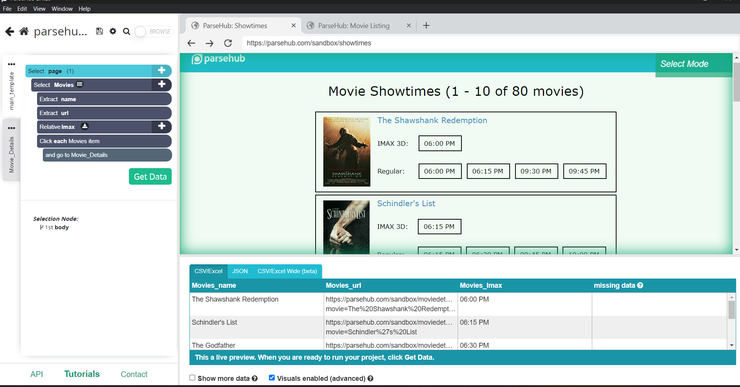

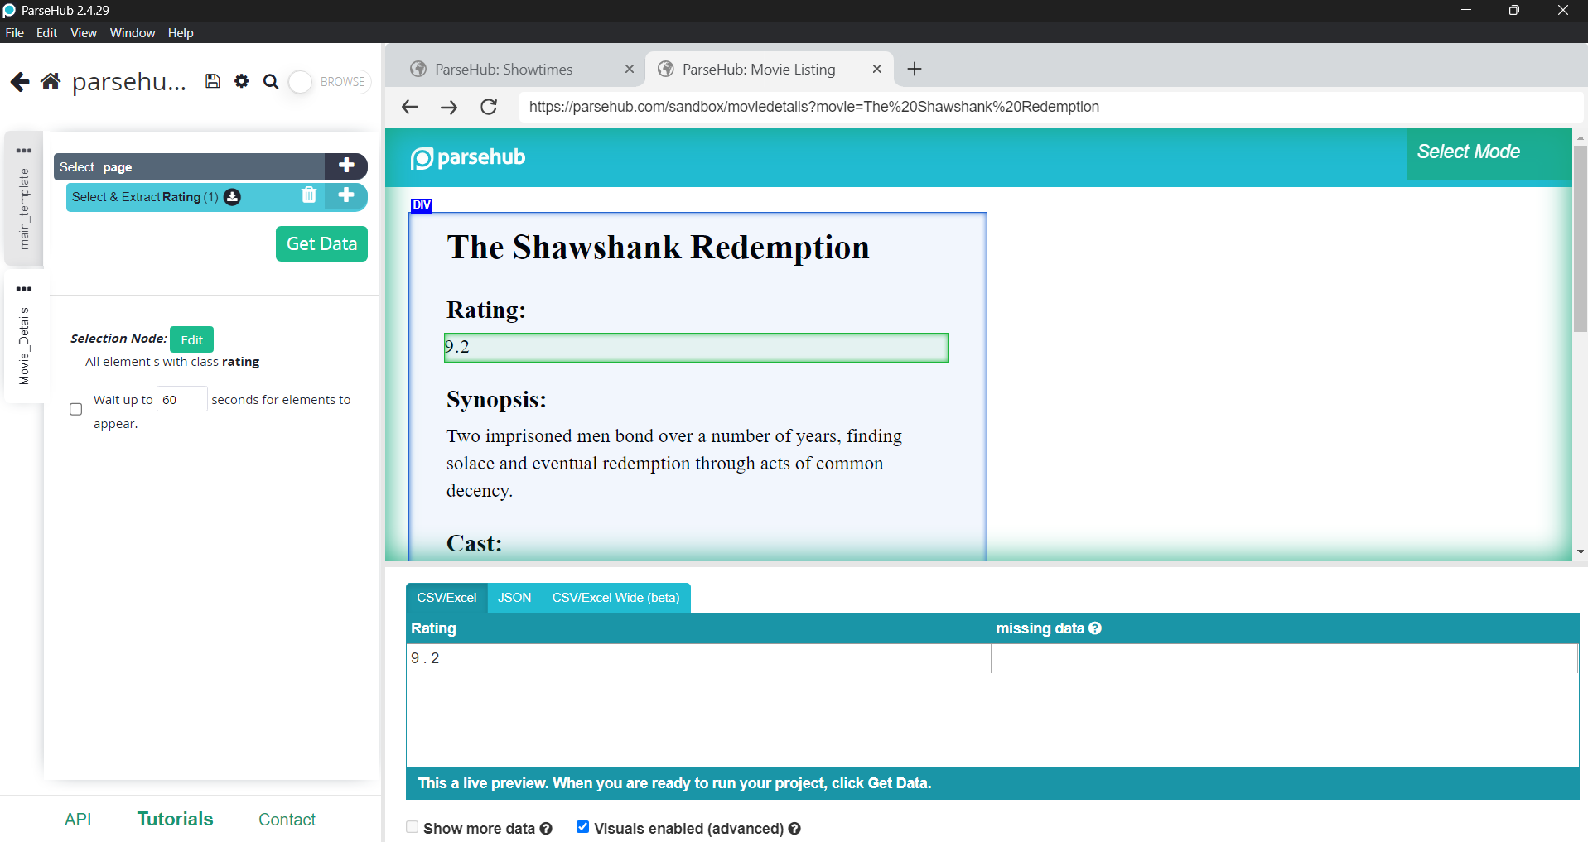

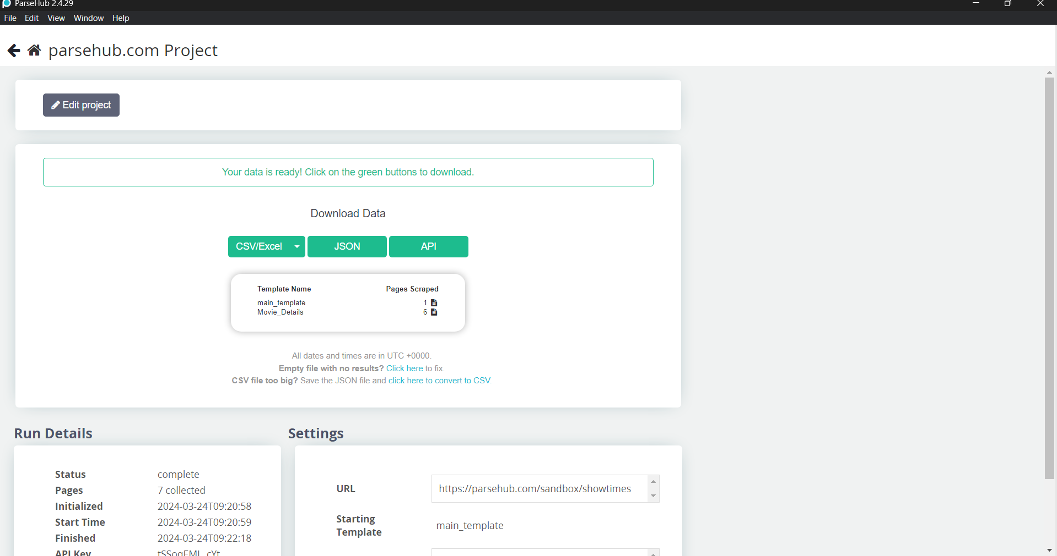

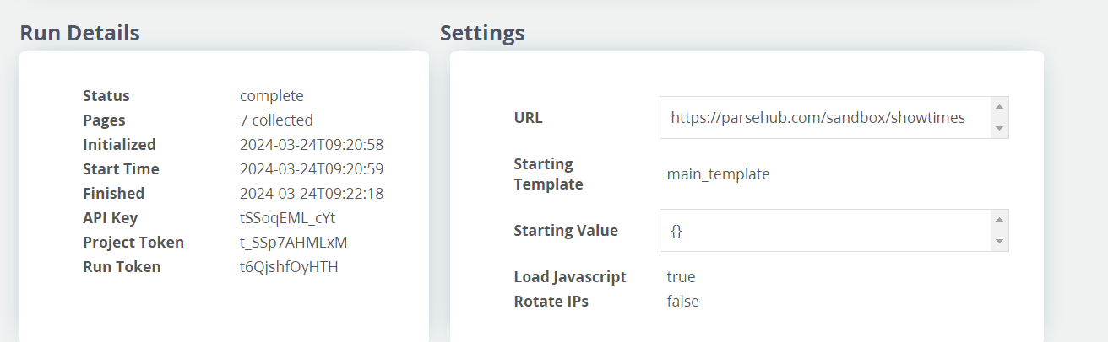

Json File:-
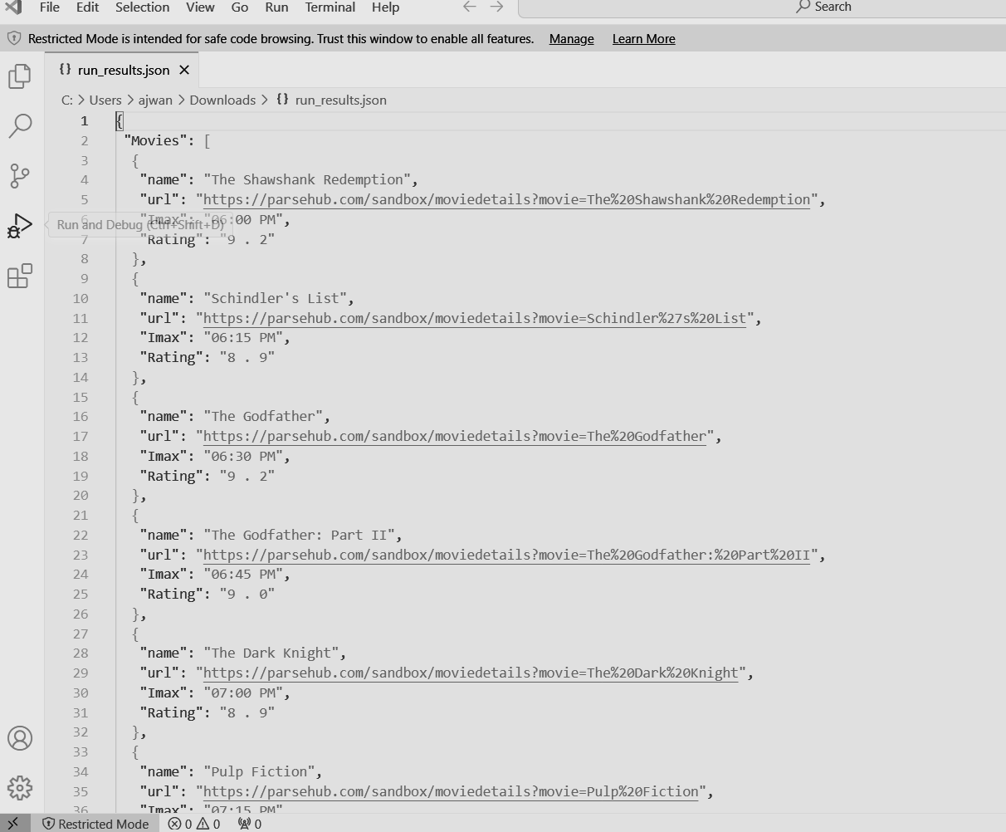

CONCLUSION:-
Hence, by combining website crawling tools like Photon or Scrapy with OSINT techniques, you can gather a comprehensive map of a website, including all its URLs, internal links, and content structure. Further analysis using OSINT fingerprinting tools like Wappalyzer can reveal the underlying technologies like CMS and programming languages. While vulnerability reports require advanced tools like Nessus, understanding the website's build allows for a more targeted security assessment. For simpler data extraction tasks, ParseHub offers a user-friendly, code-free way to scrape specific information from websites.

